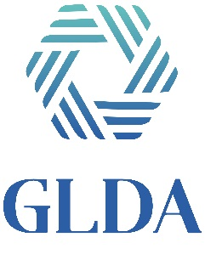
Scholarship Application
Personal Information
Name & Birth Date

Address & Phone Number

Email Address

School attending / going to attend

GLDA Member Name and relationship to Member

Name of current employer and position held

Academic Achievement
GPA & Class Rank

ACT or SAT Score

Course of Study & Career Objective & Hours taking

In / Out of state Resident & Tuition

Name of employers for the following
Father

Mother

Spouse

Due via E-mail or Mail by June 30, 2021

