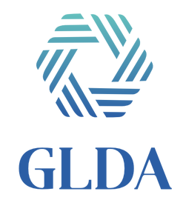
2024 Instructions for the GLDA Scholarship Application
Eligibility, Instructions & Rules for completing the Application:
- The Scholarship application and award is ONLY for an undergraduate student.
- GLDA Member must have paid 2024 dues by 2/29/2024.
- GLDA Member must have paid for and attended 1 GLDA function from July 2023 – June 2024.
- Attach the following to complete the application; judges will use all information during the evaluation process.
  - Two (2) letters of recommendation written in the current year. A counselor, teacher, co-worker or principal at the applicant’s present school must write at least one (1) of the letters of recommendation.
  - An official or unofficial school transcript.
  - A letter, written by the applicant, stating why he/she should be selected for one of the scholarship awards that lists extracurricular school activities, outside interests, organizational memberships, outside work experience, financial needs, unusual hardships, future goals, and any other pertinent information.
  - A copy of an acceptance letter from an accredited college or university.
- Last year’s recipients are not eligible. Applicant can only be awarded a maximum of 3 times.
- Applications must be received by June 30, 2024.
If applications are being mailed please send it at least one week early to ensure that it will arrive on time. The winnings will be handed out at the ceremony/luncheon. Please visit our website for more information at www.GLDA.org
Please email or mail your application to:
Fallon Adams
2331 CityWest Blvd
Houston, TX 77042

832-396-2930
Fallon.p.adams@p66.com

You will receive a conformation email when you submit your application. Please call if you do not get a response within one business day.

